Guide to Marine Sediment Core Acquisition and Accessioning into the BOSCORF collection

The British Ocean Sediment Core Research Facility (BOSCORF) is the UK’s only national deep-sea sediment core storage and research facility. BOSCORF is part of the National Oceanography Centre (NOC) National Capability (NC) and provides a unique and strategic service to the entire UK research community. Deep-sea sediment cores are an exceptional resource of immense scientific value, providing a vital source of information on the past history of Earth system processes.
BOSCORF was commissioned under the Natural Environment Research Council’s (NERC) NC Large Research Infrastructure (LRI) portfolio in October 2018. NERC NC-LRI provides for specialist, large research infrastructure that enables excellence and impact in national to global-scale environmental science.
The BOSCORF facility provides disproportionate increases in scientific returns for modest incremental investment compared to the original investment in ship time to collect the sediment cores. BOSCORF is heavily constrained by its current capacity and capability.
The specialist storage facilities currently provided by BOSCORF safeguards the ~£295 million asset investment by NERC to collect the sediment cores. Without specialist storage, sediment cores rapidly degrade (desiccate and fracture) within months, limiting their utility for further research, and resulting in a loss of assets and failure to reach full benefit realisation of multiple NC-LRIs. There is no other national repository for storing deep-sea sediment cores in the UK. A fundamental objective within BOSCORF’s mission is to have open access to sediment cores for scientists, and to promote re-usage by providing specialised facilities for the long-term storage and curation of cores.
As a necessary response to the total sediment core storage capacity being reached, on 1st October 2018 BOSCORF introduced a ‘one-in-one-out’ policy: for every sediment core received, a similar length of stored sediment core is removed and decommissioned. This will seriously degrade NERC’s ability for long term archiving of sediment cores.

Purpose of this Guidance Document
This document provides guidance to UKRI NERC funded scientists regarding the acquisition and accessioning of marine sediment samples into BOSCORF. This guidance addresses policy set out in the ‘BOSCORF Marine Sediments Collection Management System’.

Recommendations for Sample and Metadata Management
This document sets out a summary of BOSCORF’s sample management system, which adheres to international best practice. The protocols outlined here ensure that sediment cores can be reused effectively beyond the initial funded programme, and therefore benefit the entire research community. Principal Scientists are responsible for the implementation of these sample management protocols to facilitate the long-term curation of sediment core samples. If this standard practice is not followed, the preservation of the samples cannot be guaranteed by BOSCORF.

Sample Metadata
The attributes listed in the table are the minimum required metadata categories for BOSCORF samples.

Ship/Platform | Vessel name
Cruise Identifier | Expedition/cruise number
Sample Identifier | Unique within a cruise (for a sampling device), maximum 30 alphanumeric characters
Date Sample Collected | YYYYMMDD
Latitude | +/-DD.DDDDD (maximum five decimal places; - = S or W):
Longitude | +/-DDD.DDDDD (maximum five decimal places; - = S or W):
Water Depth | Corrected meters, no decimal, 5 digit integer
Sampling Device | (see device list https://www.ngdc.noaa.gov/mgg/curator/curatorcoding.html)
Storage Method | (see storage list https://www.ngdc.noaa.gov/mgg/curator/curatorcoding.html)
Core Length | 6 digit integer total length in centimetres
Core Diameter | 3 digit integer, in centimetres (round to nearest whole centimetre and place real value in comments field, if necessary)
Principal Investigator | (last name, first name of P.I.) up to 26 characters
Physiographic Province | (see province terms list  https://www.ngdc.noaa.gov/mgg/curator/curatorcoding.html)
Ocean/Sea Name
Leg | Leg within cruise, or alternate/standard leg identifier
Sediment Type | Description of sediment e.g. clay, sand, ooze, etc.
Sample Comments | Up to 2000 characters of comments pertaining to entire sample, do not use nonstandard characters

A template for recording the preferred sample metadata can be provided upon request (boscorf@noc.ac.uk).

Sample handling and labelling
After a sediment core is brought from beneath the seafloor to the deck of the ship, it is removed with its protective core liner from the outer core barrel. The core liner containing the cored material is wiped clean, and the liner is marked and cut into 1 m or 1.5 m sections. The last section may be shorter than 1 m or 1.5 m, depending on the total length of recovered core. Each section of the sediment core is capped with endcaps at the top and bottom of each section, using (38mm wide) insulation tape to seal the caps to the liner. Material in the core catcher of the outer core barrel is placed in a short section of core liner, similarly capped, and placed below the last core section.
Each section is permanently labelled with its identification number:
Core sections should be labelled numerically with the topmost section of the core labelled as Section 1, followed by Section 2, 3, 4, etc., down core.
Core sections should be labelled with appropriate way-up markers, e.g. upward-pointing arrows and top and bottom labels on end caps. If possible, two continuous lines (red and blue) should be drawn along the entire length of the core liner before it is cut into sections. This will ensure that the core sections can be split, imaged, and analysed along the same plane. This orientation marker is also important for any future palaeomagnetic analysis of the core sample.
BOSCORF would prefer sediment cores to be split under controlled conditions in the BOSCORF laboratory as part of a post-cruise splitting party. This enables essential data collection on the MSCL-S and MSCL-CIS prior physical and geochemical alterations associated with core splitting. It also enables multi-angle radiographic analysis of cores. If cores are split at sea, each half should be designated as a working and archive half and labelled accordingly.
The D-tubes and D-tube end caps used to store the core samples should also be fully labelled.
Note: It is the responsibility of the Principal Scientist to purchase D-tubes. Cores will not be accepted into the BOSCORF collection without D-tubes.

BOSCORF standard for sample naming
The BOSCORF sample naming scheme follows international best practice. Similar schemes are used by the International Ocean Discovery Program and the Continental Scientific Drilling Facility.
The sample identifier must be unique within a cruise and should be composed of the following components:
- Cruise identifier
- Coring device
- Core number
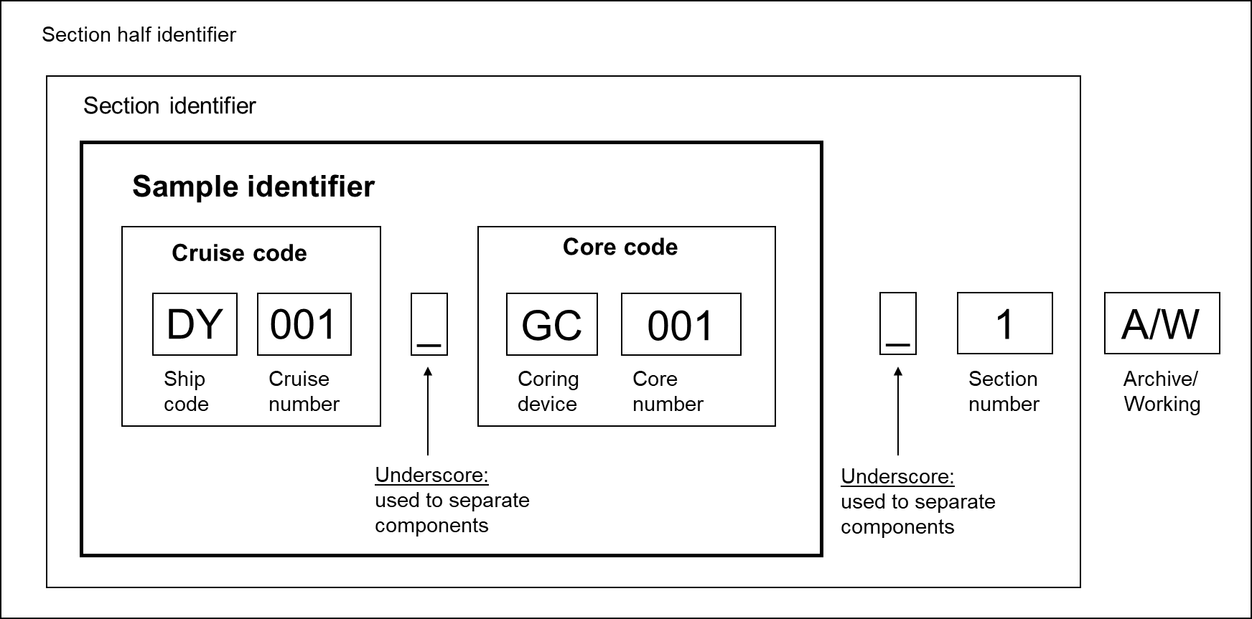
The unique sample identifier and labelling should follow the format shown below:

In the example shown above:
- Sample identifier: DY001_GC001
- Section identifier: DY001_GC001_1
- Section half identifier: DY001_GC001_1A or DY001_GC001_1W
Note: It is compulsory that sediment cores are named using this standard. BOSCORF will rename sediment cores entering the collection that are not in this format.

Reserving sample storage
For samples originating from expeditions funded by NERC, it is the responsibility of the Principal Scientist to ensure that there is storage space available to accommodate the incoming samples prior to the expedition. Sample storage requirements should be discussed with the BOSCORF Curator during the project planning phase to determine if storage space can be allocated. BOSCORF is at maximum capacity and cannot guarantee that samples can be stored in the repository. Samples that are approved for accessioning must be accompanied by complete sample information, sample metadata and conform to BOSCORF sample standards.
Note: samples that are in poor condition and are of limited scientific value may not be accepted. Due to space limitations replicates samples will not be accepted without scientific justification. BOSCORF is a sediment core repository at capacity; non-sediment core material will not be accepted.
An accession record form will be issued following the transport of sediment cores to the BOSCORF repository.

Accessioning
On delivery of the samples to the BOSCORF repository, sample condition is evaluated, and all metadata are checked and uploaded to the BOSCORF inventory. All samples are relabelled to conform to the BOSCORF standard (if necessary) and racked/shelved. All piston and gravity sediment cores are systematically logged on the standard Multi Sensor Core Logger (MSCL-S) within 3 months of entering the repository. The data quality is highest from unsplit ‘fresh’ sediment cores. Therefore, it is BOSCORF policy to collect MSCL-S data as soon as practicably possible. This data is made available to the Principal Scientist within 1 month of analysis.
With the agreement of the Principal Scientist, all piston and gravity sediment cores are split, and line scan imaged (on the MSCL- Core Imaging System). This is followed by the collection of spectrophotometer and magnetic susceptibility data from the MSCL-XYZ system. This data is made available to the Principal Scientist within 1 month of analysis.

Sample moratorium
Sampling requests received within 3 years of sediment core collection will be passed to the Principal Scientist who will assess whether the request conflicts with their own research interests. If there is no conflict the request will be granted. If there is a conflict the sampling request will need to be resubmitted after the 3-year period.

Sample discovery
During the moratorium period basic sample metadata will be listed on the BODC cruise report webpage (https://www.bodc.ac.uk/resources/inventories/cruise_inventory/search/) and on the BOSCORF repository holdings webpage (https://boscorf.org/repository/repository-holdings). Beyond the moratorium period, sample metadata for cores accessioned to the BOSCORF collection will be listed on the Index to Marine and Lacustrine Geological Samples (https://data.nodc.noaa.gov/cgi-bin/iso?id=gov.noaa.ngdc.mgg.geology:G00028).

Subsampling of sediment cores
Records of sediment core subsampling should always be provided to BOSCORF. There are no restrictions on subsampling by the cruise principal scientists during the moratorium period. Requests sent to BOSCORF for subsampling during the moratorium period will be communicated to the principal scientist for approval.

Secondary sampling of sediment cores
Secondary sampling refers to subsampling of cores beyond the moratorium period and it is the authority of the Curator to approve a sample requestor’s suitability for secondary sampling. Requests are evaluated by the Curator based on sample availability and the scientific merits of the request. The BOSCORF Advisory Group is consulted for evaluating core-top samples and large volume requests.
Sample request forms can be downloaded from the BOSCORF website (https://boscorf.org).

Analysis of sediment cores
Requests for core-splitting and non-destructive measurements on sediment cores should be submitted to the Curator at the earliest possible time. Principal scientists are advised to contact BOSCORF to discuss the analytical requirements of their projects prior to research cruises and expeditions taking place.
Note: It is the responsibility of the Principal Scientist to provide an extra 3 meters of empty core liner. It must be the same liner used to collect the samples. This is essential for calibration of physical property measurements on the MSCL-S and ScoutXcan

Analysis request forms can be downloaded from the BOSCORF website (https://boscorf.org).
Core splitting and non-destructive analyses are overseen by BOSCORF staff, but it is expected that the project PI and/or project participants will assist with core sample processing, analysis and associated laboratory activities.

Data moratorium
According to the NERC data policy: “NERC expects everyone that it funds to manage the data they produce in an effective manner for the lifetime of their project, and for these data to be made available for others to use with as few restrictions as possible, and in a timely manner”.
It is the responsibility of individual researchers and principal scientists to submit data to the appropriate NERC data centre.
BOSCORF archives all raw data acquired from its suite of non-destructive analytical instruments. These data are typically protected by a two-year moratorium during which time the data are available only to the project participants. For lengthier projects and for projects that are associated with PhD studentships, it may be possible to protect the data by a moratorium extending for a maximum of five years.
At the end of the agreed data moratorium, raw data will be made openly available and accessible by request to the Curator.

